

**Project Planning Phase**

**Project Planning Template (Product Backlog, Sprint Planning, Stories, Story points)**

|  |  |
| --- | --- |
| Date | 27 June 2025 |
| Team ID | LTVIP2025TMID59552 |
| Project Name | HealthAI-Intelligent Healthcare Assistant Using IBM Granite |
| Maximum Marks | 2 Marks |

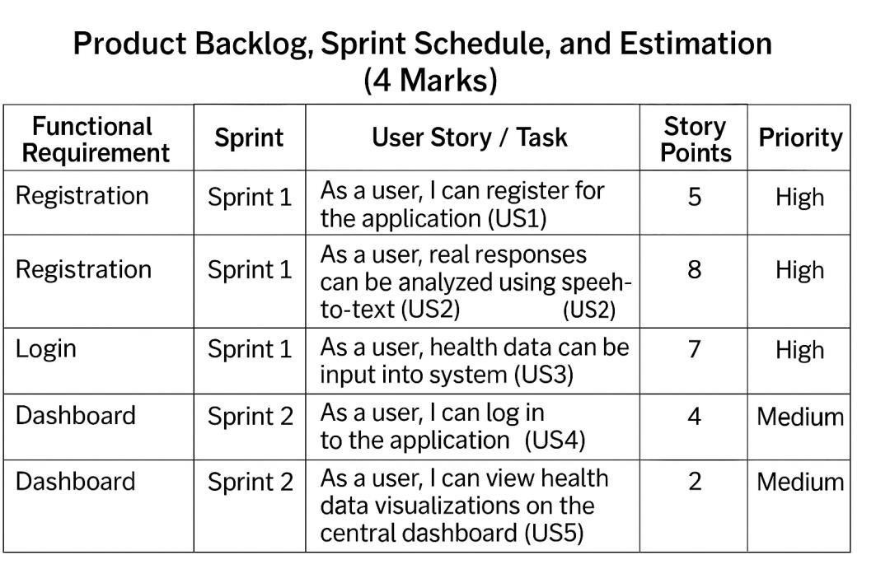

**Velocity:**

Imagine we have a 10-day sprint duration, and the velocity of the team is 20 (points per sprint). Let’s calculate the team’s average velocity (AV) per iteration unit (story points per day)



